Room 1:

Role of SOC level 1:
Following is the role of the SOC level-1:
The soc level 1 spends it most of the time in triaging the alerts and can monitor alters 24/7
- Monitor and triage the alerts 24/7
- Deploy and configure security tools
- Draft the basic level rules and signatures of the IDS
- Create tickets and escalates the incidents to the SOC level 2 and team lead
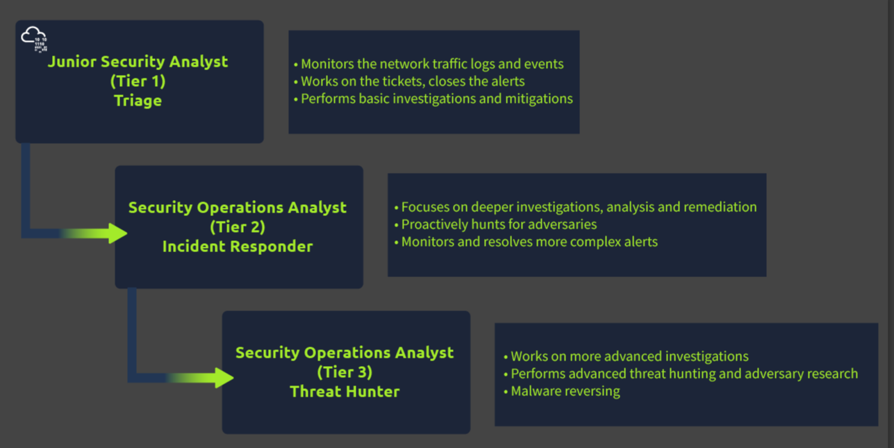

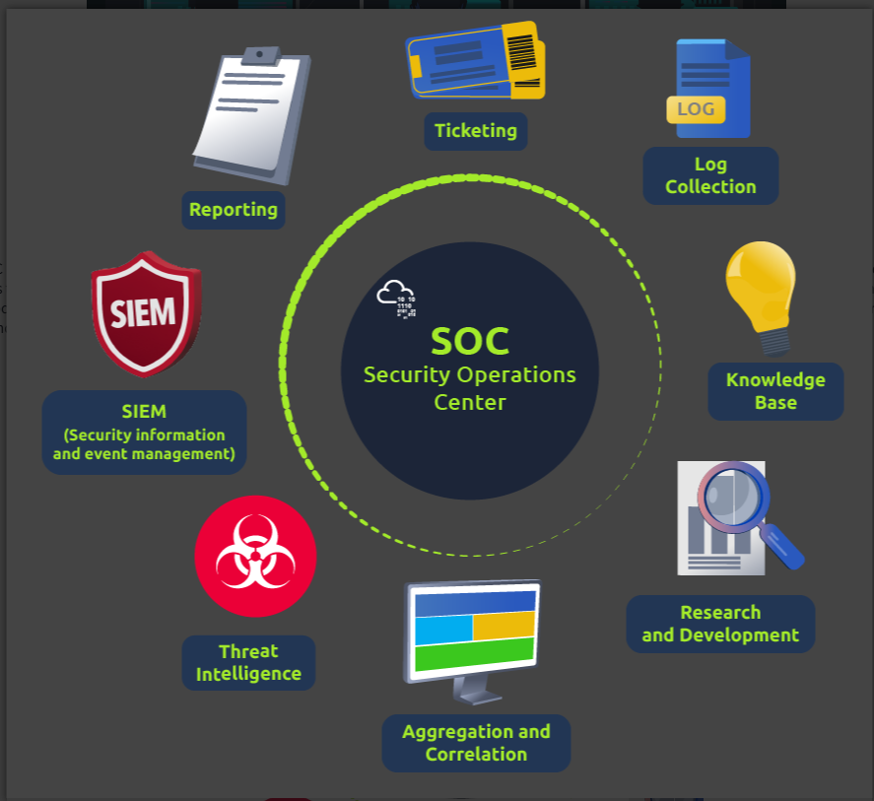

Preparation and Prevention
In the preparation phase the SOC analyst remains up to date with the latest cyber threat actors, latest threats, emerging attack groups through different feeds from social media
Preventions Phase:
In this phase the SOC analyst investigates, monitor, prevent and respond to the threat by closely monitoring the TTP’s tactics, techniques and procedures.
Monitoring and Investigation:
In Monitoring phase, the soc analyst deploy the several tools i.e., SIEM (Security Information and event Managements system) and EDR (endpoint detection response) to monitor network activities. It is very essential for the SOC analyst to priorities the alerts i.e., low, medium, high and critical.
The junior analyst has a vital role in triage investigation. It starts its investigation from How, When and Why and identify the threat actors and mitigate the threat.
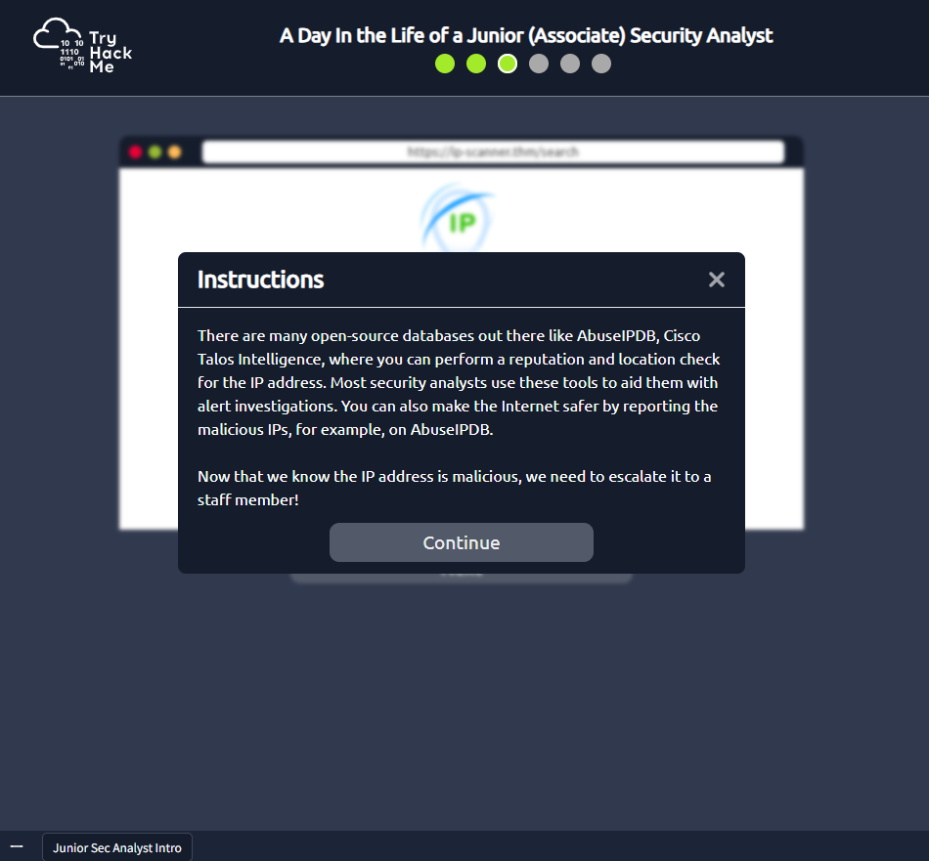

Note: a soc analyst did not worry about the failed login attempt but it is worried about the
Successful login attempt from a malicious ip.

Blocking a malicious IP address:

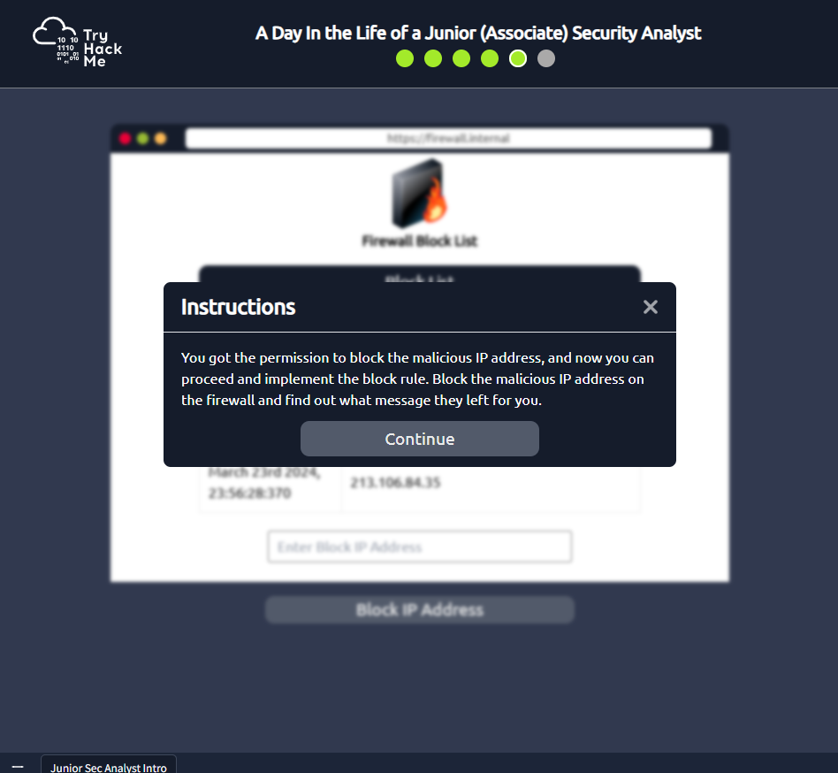

The Flag of First Room:
